Skyler Hart

ITEC 4501 Special Projects in IT

Library Game

03 Feb 2016

**Act 3 – Terminal MiniGame – Project Storyboard**

## Descriptive Text from “Act Three of Tesla’s Revenge” Document:

Minigame

When a player tries to open a door to a side room, a terminal requesting access will appear. Opening door = start of minigame. (This minigame may take students longer to solve, because students will be required to read carefully before offering solutions). On the terminal, students will be presented with an excerpt of at least four or five sentences from an article (fictional). They will then be given sentences that are either identical or have a similar concept to the previous sentences. The students will have to determine whether the second set of sentences is a paraphrase, summary, or direct quote of the first set of sentences. Once the door opens, students will either find a key fragment, an article fragment, an npc, or nothing.

    General Setup

        Number of Doors 8

* Six side rooms
* One exit
* One entrance

        Number of Items to be found

* Three key fragments
* One npc
* The final article fragment for the death beam

Table to be used for Terminal

|  |  |  |  |
| --- | --- | --- | --- |
| Article Excerpt | Paraphrase | Summary | Direct Quote |
| The | amount | of | “” |
| words | in | these |  |
| boxes | is | astonishing. |  |
| Still working | on it. |  |  |
|  |  |  |  |
|  | Nothing to | see here _(O.O)_ |  |

A librarian can appear at anytime during the activity to encourage students or explain paraphrasing, summarizing, or directly quoting an article. After the player successfully gains access to all the side-rooms and finds or assembles a key, he or she will be able to continue on the journey to the games end.

## Terminal Sketch:

When the player opens one of the doors, a terminal scene will be loaded. The terminal scene will be a 2D scene similar to the following:

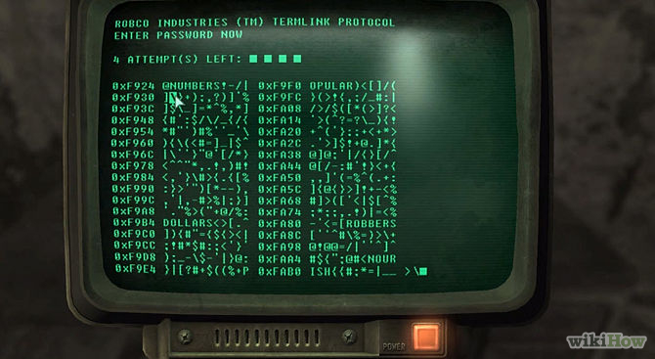

The look will be similar to that seen above; an old-school, ASCII terminal with a greenish tint. The terminal will appear when the scene is loaded, initially blank with a block cursor flashing.

The screen will have three columns, divided by thin lines on the screen. After a couple of seconds, the leftmost column will show:

### Please read the text below very carefully:

After pausing for a couple of seconds (with the green cursor flashing just after “carefully:”), the article excerpt will be printed on the left side of the terminal:

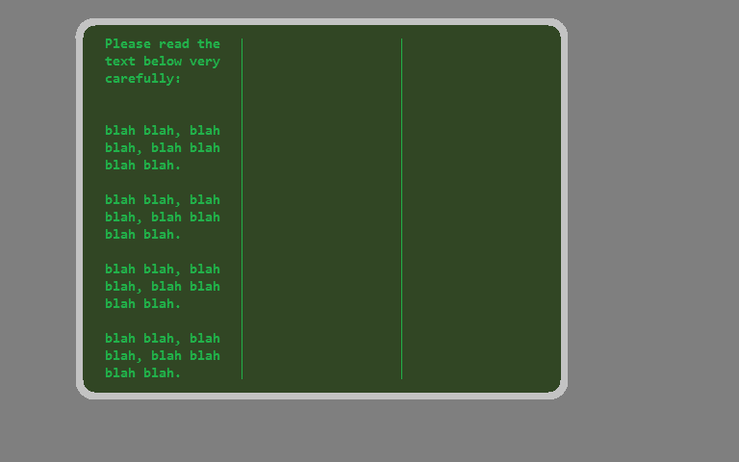

***(These are rough sketches, just for storyboard purposes)***

After pausing for 15 seconds (or another amount of time, long enough to allow the player to read the text), the following message will appear in the second column:

### Compare the text below to what you read in the first column:

Followed after two seconds by the comparison text in the second column:

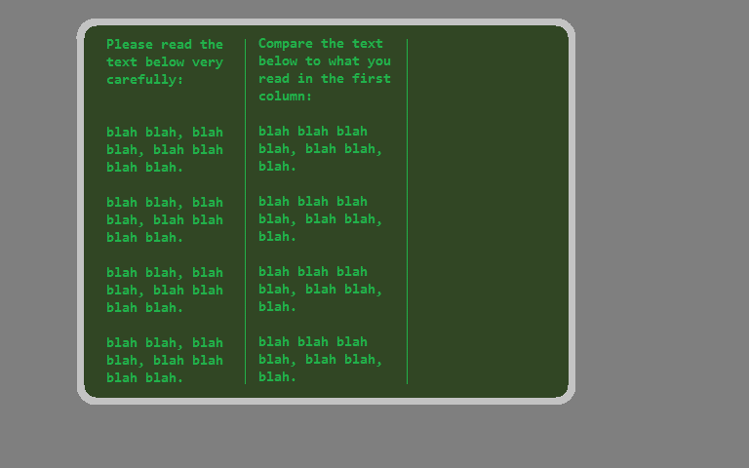

After pausing for 15 (or another amount of) seconds, the final column will display, asking the user to select whether the second column’s text was a paraphrase, summary, or direct quote of the first column’s text. The following message will be displayed:

### Was the second column a paraphrase, summary, or direct quote of the first column?

After two seconds, the player will be prompted with the text: P, S, or Q: as seen below:

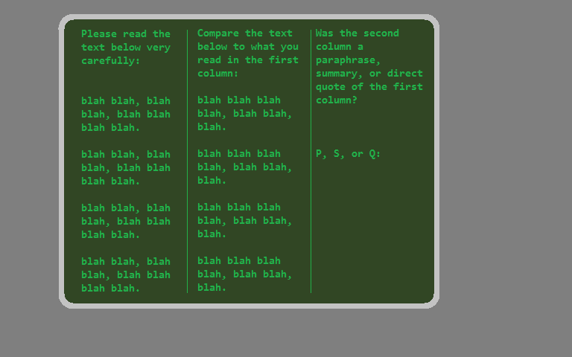

If the player answers correctly, they will receive a short congratulatory message, and then will be granted access to the room that they were trying to enter:

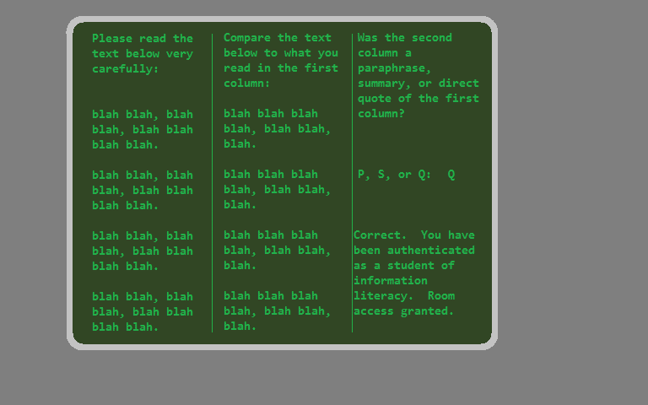

If the player answers incorrectly, they receive notice that they will be connected with the Library HelpDesk:

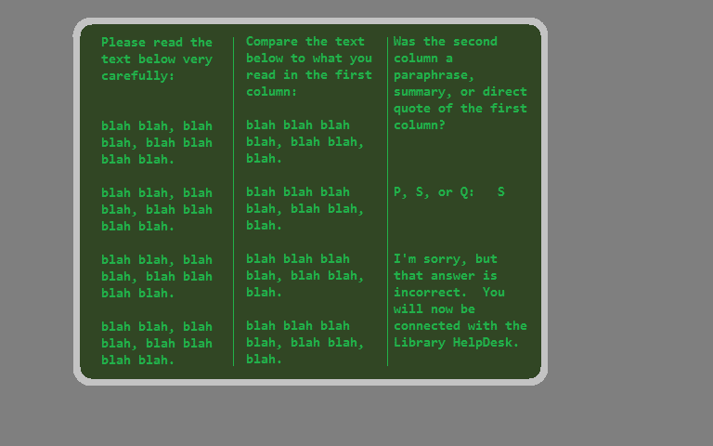

## Library HelpDesk:

If the player has answered incorrectly and arrives at the HelpDesk, the terminal screen will clear, and the user will be presented with the following prompt:

### Welcome to the Library HelpDesk. The correct answer was [whatever the correct answer was]. Please review the following information about [the correct answer]:

This will be followed by information about how to determine that something was a paraphrase, summary, or direct quote, as appropriate.

After this information is presented, the user will be given the following prompt:

### You may now review additional information or retry the room authentication process. Enter “P” for information about paraphrasing, “S” for summary, or “Q” for direct quote, followed by the Enter key. Press any other key or Enter alone to exit and retry.

### P, S, Q, or Enter: